Project Design Phase-II
Technology Stack (Architecture & Stack)

Date | 03October 2022
Team ID | PNT2022TMID35794
Project Name | Project - Smart Solution for Railways
Maximum Marks | 4 Marks

Technical Architecture:

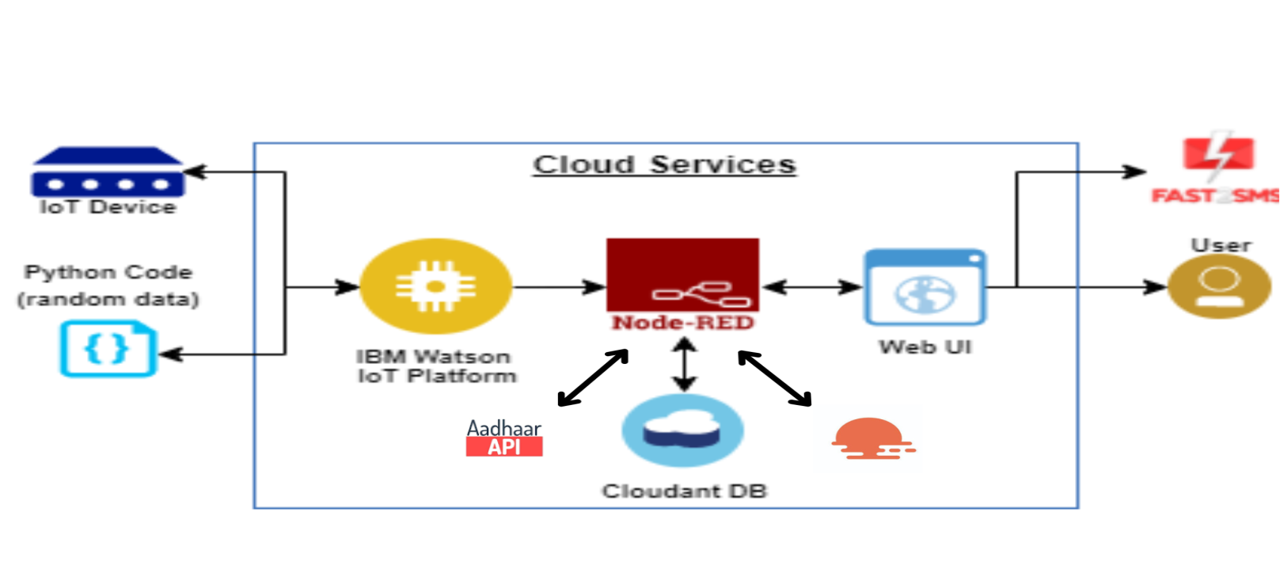

Table-1 : Components & Technologies:
S.No | Component | Description | Technology
 | User Interface | Web UI, Mobile App | HTML, CSS, JavaScript
 | Application Logic-1 | Node Red to write logic programs for the system | Python(Node Red)
 | Application Logic-2 | To add and manage control access to IOT service | IBM Watson IOT Platform
 | Database | Tabular format | MySQL.
 | Cloud Database | Database Service on Cloud to store user data for reuse and store ticket availability information | IBM Cloudant DB
 | File Storage | File storage requirements for administration purposes on a periodical basis | Local Filesystem
 | External API-1 | To determine the weather condition at a particular latitude and longitudinal co-ordinates | IBM Weather API
 | External API-2 | To verify and process user information and ID proof | Aadhar API
 | Infrastructure (Cloud) | Application Deployment on Cloud | IBM WATSON SERVICES

Table-2: Application Characteristics:
S.No | Characteristics | Description | Technology
 | Open-Source Frameworks | MySQL | Relational database management system
 | Security Implementations | Aadhar API | MongoDB-Works on biometric algorithms
 | Scalable Architecture | 3-tier micro service for registration, login and booking | Python(Node-RED)
 | Availability | User interface for application and web UI | HTML, CSS, JavaScript
 | Performance | Stores the user provide details and ticket availability status and updation | Cloudant DB

